CSE 460

Socket Project

Milestone

Group 71

Yazid Alsaeed

1227005574

Abdullah Althobaiti

1227005015

1. Description of commands

We will receive a message from the user to decide which command to execute

1. Register:

The user will send the handle name without the command number which is an indication to register the handle

1. Query handles:

The user will send “1” which is an indication to send back the query handles to the user

1. Follow:

The user will send “2” and the program will ask for the name of the user who want to follow, then the user send “2 HandleName” to the Tracker. “2” is an indication to execute the follow function and “handleName” the intended user

1. Drop:

The user will send “3” and the program will ask for the name of the user who want to follow, then the user send “3 HandleName” to the Tracker. “3” is an indication to execute the drop function and “handleName” the intended user

1. Exit:

The user will send “0” and the program of the user will close then the tracker will delete all the information about the user. “0” is an indication to execute the exit function

1. Tweet:

The user will send “4” and the program of the user will send for all the followers of him the user who are in the left and the right and then it will create the logical ring and then the message will propagate from user to user until in it return the user and it will send end-tweet

1. Time-space Diagrams

Register:

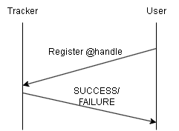

Query Handles:

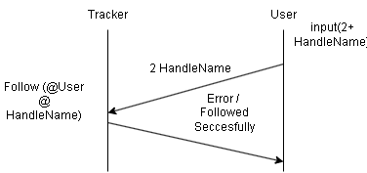Follow:

Drop:

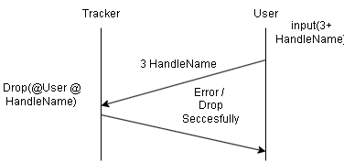

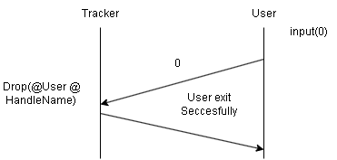Exit:

Tweet:

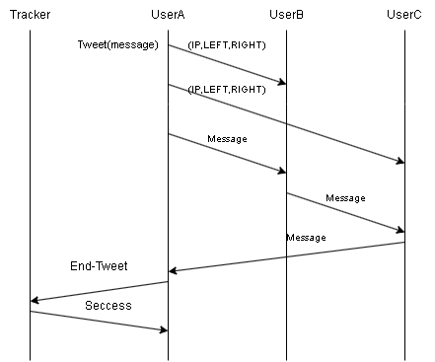

1. We decide to create handle as a class to make use from Object-Oriented concept and make it easier for us to store and modify any change on the handles information, IP, ports, and we create a list to store the followers so that it is easy for us to drop and add and every handles will have followers and following list. We create a function for every command which associated it with the class handles and the class help us.
2. Commits picturesA screenshot of a computer

   Description automatically generated with low confidence

